Event Registration System:
User Guide

Table of Contents
Chapter 1 Introduction 4
Overview 4
Log into the Event Registration System 5
Chapter 2 Administration Module 7
Overview 7
Global Administrator Level 7
Portal Administrator Level 11
Organizational Administrator Level 14
Chapter 3 Events Dashboard 15
Chapter 4 Create a New Event 16
Event and Payment Details 16
Event Name 16
Refund Policy 19
Discount Codes 19
Administrative Contact 21
Registration Dates 21
Registration Types 22
Error Notifications 24
Event Setup 25
Activity Details 25
Registration Form Setup 28
Registration Information 28
Event Capacity 30
Waiting List 30
Event Homepage 31
Content 31
Document Links 32
Verify Event Information 32
Chapter 5 Duplicate an Event 33
Chapter 6 Event Management 34
Event Summary 34
Event URL 35
Actions 35
Details 35
Attendees 36
Registrant Information 37
Delete Attendee 38
Export 39
Edit Event 39
Add Attendee 40
Start Registration 40
Information 41
Activity Details 43
Contact Information 44
Waiting List 46
Chapter 7 Payment Process 47
Customer Billing Information 48
Credit Card Information 49
Verification 50
Electronic Check Information 51
Verification 52
Payment Confirmation 52
Chapter 8 Name Badges 54
Name Badge Information 54
Chapter 9 View Waiting List 57
Chapter 10 Email Notifications 58
Email Messages: 58
Chapter 11 Reports 59
Report by Date 59
All Event Data 60
Chapter 12 Disable Event 61
Reactivate Event 62
Chapter 13 Session Timeout 63

Introduction

Overview
Arkansas’ Event Registration System is an online event management solution that enables users to easily create, organize, and manage a variety of events. The system automates key tasks such as registration, reporting, payment acceptance, and event management.
This User Guide will guide Event Administrators through the process of creating, editing, and managing events.
If you have any questions about the operation or functionality of Arkansas’ Event Registration System or need more detailed instruction, please contact the Arkansas.gov Service Desk at 501-324-8900 or 1-877-727-3468 or email at info@ark.org.

Log into the Event Registration System
- Go to the Arkansas’ Event Registration System website located at the following url: https://events.egov.com/eventreg/ar/login.htm

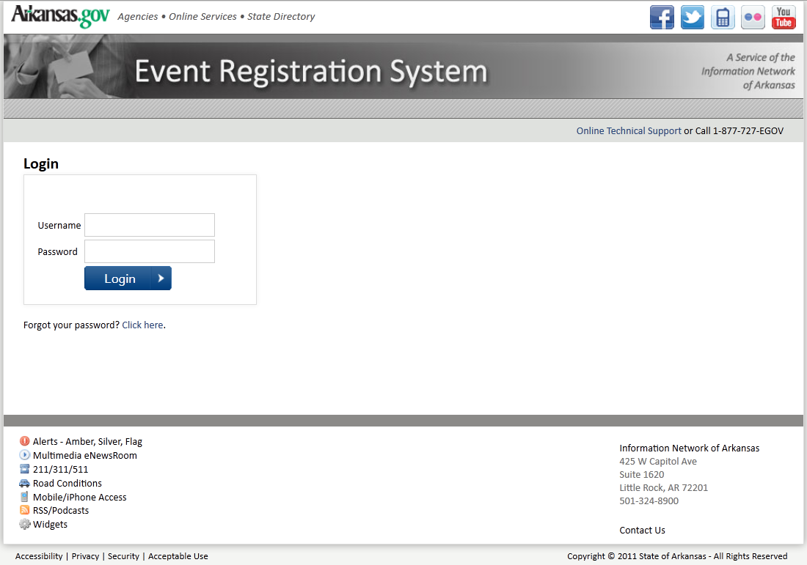

- Enter your User ID and Password.
NOTE:
For User ID and Password assistance, please contact the Arkansas.gov Service Desk at 501-324-8900 or 1-877-727-3468 or email at info@ark.org.
- Then click Login.
- The Password Reset feature allows users to manage their own passwords and is accessed by selecting “Click here” following “Forgot your password?”

Administration Module

Overview
- Based on role, users are routed to one of three a separate interfaces corresponding to the appropriate level of administration a user is assigned.
  - Global Administrators serve as support staff at NIC’s Corporate Data Center. They have full permissions (create/delete and edit) for portal-administered accounts and delegate all other administrative functions to the portals.
  - Portal Administrators have full permissions for a specific portal assigned by the Global Administrator and can assist users in any organizations within that portal. Portal administrators do not have any permissions (create/ delete, edit or view) for any other portal or any organization within any other portal.
  - Organizational Administrators are agency partners with full permissions for their specific organization. Organizational administrators do not have any permission for any other organization within their own portal or within any other portal.

Global Administrator Level
The global admin consists of two primary features: managing a list of portals (states) and managing the users in those states. Global admins will create a state and the first user in that state. Those users can then create more users in their own state.
- This page will list all portals in the system. Click on a portal to manage it, or click "Create new portal.”
- Once created, portal names cannot be edited. The portal can be deleted, which will delete all information associated with that portal. A confirmation box informs the user that this will delete all users and events associated with that portal and require confirmation.
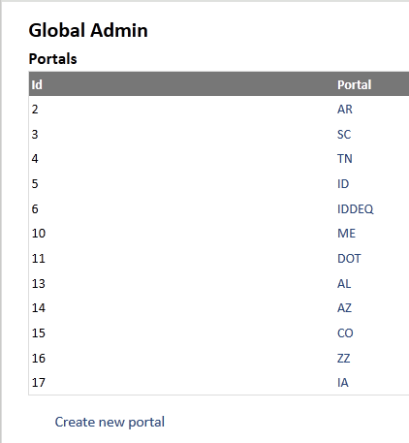
- Only one user will be created initially. The user will be created as a "PortalAdmin" and will have the ability to create other portalAdmin users within the same portal. The system will send an email to the user with a password reset link. Passwords will not be transmitted via email.
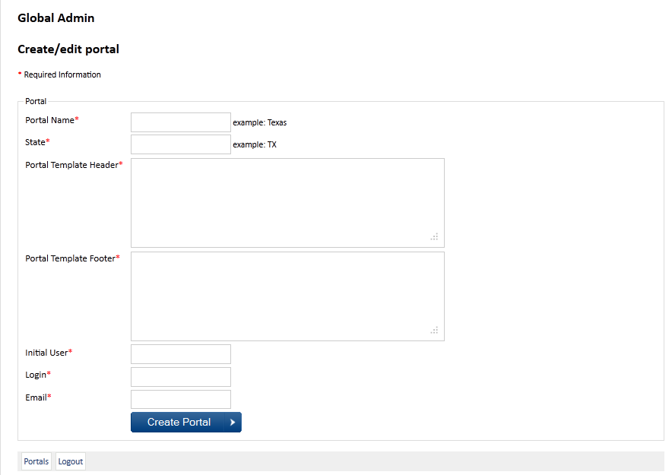

- This page will list all users in the portal.
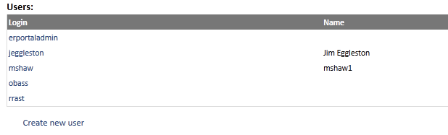

- Click a user to edit or create a new user. Users can be added to a portal one at a time after the portal is created. The system will send an email to the user with a password reset link. Passwords will not be transmitted via email. Once created, only the user's name and email can be changed. Users can also be deleted.
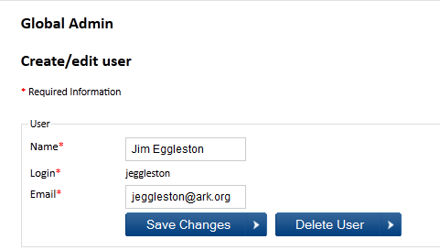

Portal Administrator Level
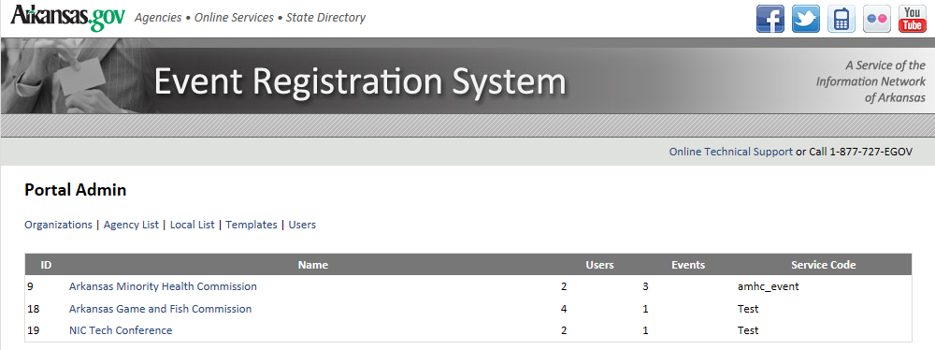
The portal admin allows users at a portal to manage all aspects of the portal. Note that this involves changing the way templates work. Templates are currently assigned to portal but portals have a need for multiple templates.
- There are 5 major features of the portal admin, which are arranged into a tab interface.
  - "Organizations" allows a portal to manage and create organizations and users.
  - "Agency list" allows administrators to manage the list of agencies that appear in events created by that portal.
  - "Local list" allows administrators to manage the list of agencies that appear in events created by that portal.
  - "Templates" manage multiple html templates, which are available to organizations.
  - "Users" allows the portal to create and manage other portal user accounts.

- Organization tab
  - This tab lists the organizations assigned to this portal. It provides a summary of users, events and the service code assigned.
  - The user clicks the organization name to edit it or selects “Create new organization” in order to create a brand new organization.
  - Service Codes:
    - Click on the service code to edit the merchant, service, key, trace and vendor. Or, the user can click add service code for create a new one. This drop down contains service codes from the service code table.
    - There are two options for applying service codes to the organization:
      - Associate all events for this organization with one of the service codes in the drop down list.
      - Or, a portal administrator must choose the service code for any events created by this organization.

  - Email templates:
    - The Email template text box allows the administrator to add the text directly in without needing to code HTML.
    - The Email template waiting text box works the same way in that it allows the administrator to add the text directly in without needing to code HTML.
  - Webpage Template:
    - Note that the template is now chosen from a list of templates for that portal, rather than being assigned by the state.
  - User
    - The create page allows the admin user to create 1-3 users. The users will be emailed password reset links.
This comma separated list of emails will receive a notification whenever a new event is created.
When editing an organization, anything can be changed except the id number. Orgs can be deleted, but a prompt should warn the user that all events and users will be deleted and require confirmation. Additionally, users can be created and modified.

See the global admin for interfaces for user creation, modification and deletion. Only user names and emails can be changed once created. Emails should never be displayed or emailed, password reset links should be sent instead.

Portals can manage the state and local agency lists that are associated with events. Items can be added to the list, or renamed at any time. If items are deleted from the list, however, any events/registrations making use of that list item will need to be addressed - possibly by setting to an "unknown" value.
"Edit" should bring up a popup or other page to edit multiple names at one time.
Multiple list items can be added at a time. Add one per line
Currently, EventReg has one template per portal. This change will allow for more flexibility. Each portal can create multiple templates, and organizations can choose from a template.
Display the size in KB of each template, and a link to preview the template.
Click on a template name to edit, or create a new template.
Provide a list of organizations that use this template, and disable the delete button if the template is in use.
EventReg should provide a standard password reset capability for all users.
A notification has been sent to the email address associated with this account.
An email is sent to the account that matches the username or email address. The email contains a time-limited, one-use token that will direct the user to event reg to change their password.
Error: No account was found with the email address or user name.

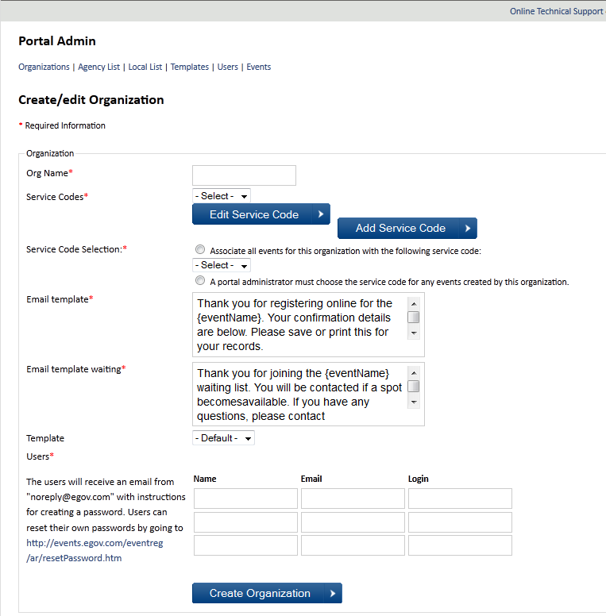

Organizational Administrator Level
- Description of Key aspects of Org admin Level
- Introduction to Event Management- Spell out each area of Event Management that we’ll take on for the rest of the user guide.
  - Events Dashboard
    - What each column tells us
    - Duplicate Event
    - Initiate Create a New Event
    - Initiate Edit Existing Event

Events Dashboard
The Events Dashboard is the main page for administrators at the organizational administration level. Upon login, the dashboard will display all the Events created by Event Administrators from your agency or organization. As new Events are created, they will be listed here by Event Name.

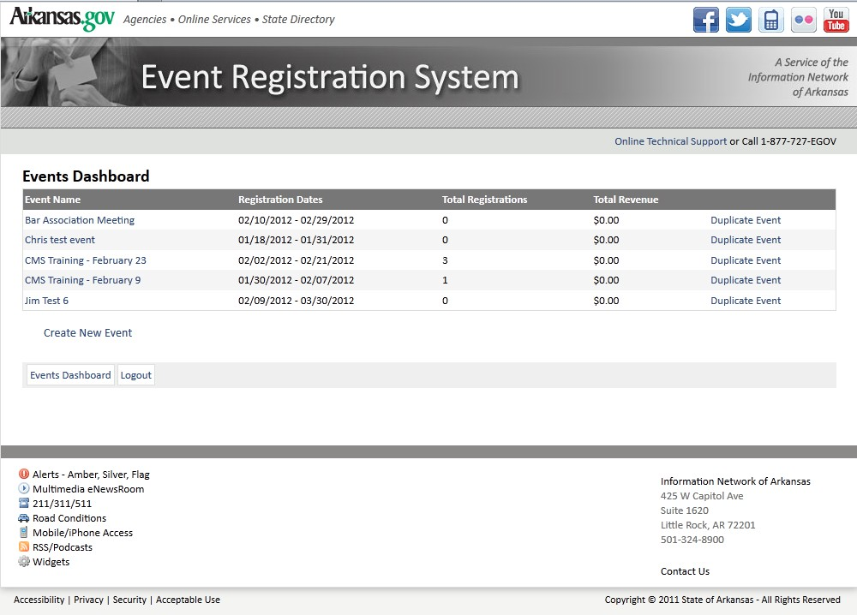
NOTE:
Past, present, and future Events will all be listed here, but Events that have already taken place or ones that have been disabled cannot be edited. You can run reports from past or disabled Events.

Create a New Event
- Click on Create New Event on the Event Dashboard screen.
The following sections describe how to configure all available options for this new Event.

Event and Payment Details
The first screen that displays is the Event and Payment Details screen.
NOTE:
All fields with an asterisk (*) are required. You cannot continue to the next screen if a required field is left blank or the content does not meet required parameters.

Event Name
Enter the Event Name.
The name entered here will be seen by the Registrant; so, please choose a name that clearly describes the Event.
Decide if a password will be required to register. If so, click on the This event will require a password option.
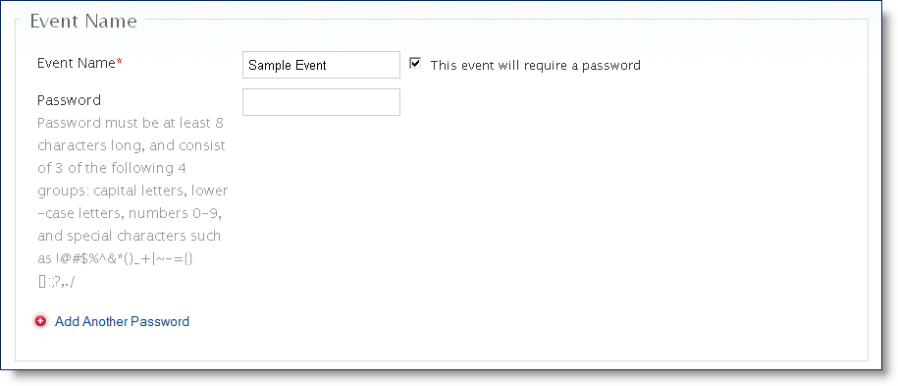
Passwords can be used to limit registration to a specific group, and multiple passwords can be used for a single Event.
The Password you choose must be at least 8 characters long, and consist of 3 of the following 4 groups: capital letters, lower-case letters, numbers 0-9, and special characters such as !@#$%^&*()_+|~-={}[]:;?,./.
REMEMBER:
If you choose the password option, you must provide the password to all registrants to ensure a smooth registration process.
To use multiple passwords click on the Add Another Password option.
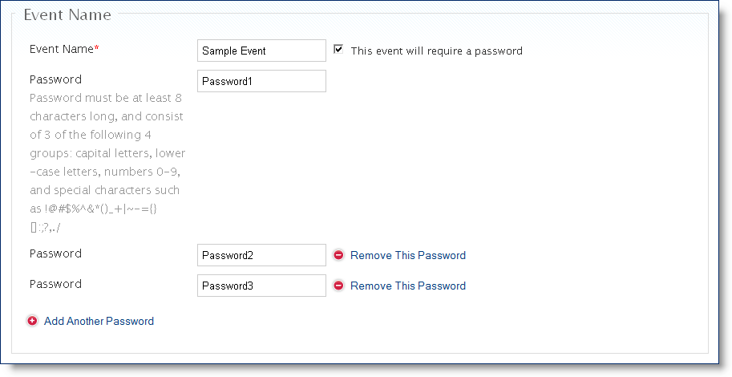
Individual passwords can be removed at any time by clicking on the Remove This Password option.
The requirement for an Event registration password can be removed at any time by unchecking the This event will require a password option.

Refund Policy
The Refund Policy must be completed, even if you are not charging a registration fee.
IMPORTANT:
Refunds are NOT system generated. You must describe the process for registrants to request a refund and your organization will have to manually process a refund. Make sure to have a refund policy and process in place and to clearly communicate this process/policy to registrant including 1) who to contact and 2) how long the process takes.
Describe the Refund Policy to registrants.
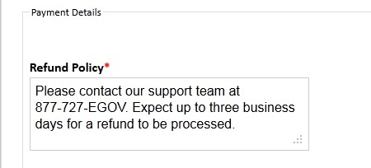

Discount Codes
Determine if you will allow discount codes. Discount codes are used to reduce the total cost for the registrant. If so, click on the Allow discount codes option.
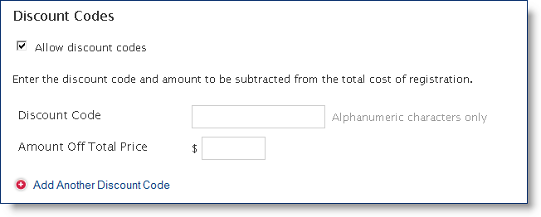
IMPORTANT:
Discount codes can be used multiple times and there is no system functionality that prevents someone from sharing their discount code with others. When dealing with individual or small group discounts, you can employ a clever naming technique to make the user believe the code can only be used one time. For example: 4 digits of their last name plus a number (Smit045).
Enter a Discount Code (using a maximum of 10 alphanumeric characters only).
Enter an Amount Off Total Price. This is the price with the discount applied and it must be a dollar amount.
To use multiple discount codes, click on the Add Another Discount Code option.
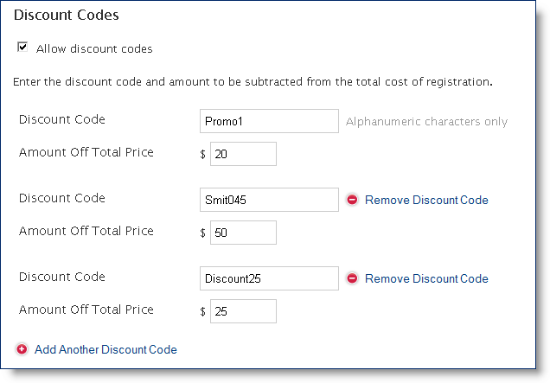
Discount Code Removal
    - Individual discount codes can be removed at any time by clicking on the Remove Discount Code option.
    - Overall Discount code functionality can be removed at any time by unchecking the Allow Discount Codes option.

Administrative Contact
The administrative contact is required. It will be displayed on the registration pages and in the confirmation email after registration is complete.
Enter the Administrative Contact Name, Email Address and Phone number.
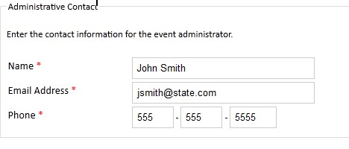

Registration Dates
Registration begin and end dates are required. There is also an option to allow early or late registration.
NOTE:
If you add early or late registration, you can set different registration fees. This is useful if you want to offer an incentive for registering early or apply a penalty for registering late.
Enter dates for Registration Begins and Registration Ends by clicking on the field and using the date widget to select a date.

The date widget makes it easier to enter dates.
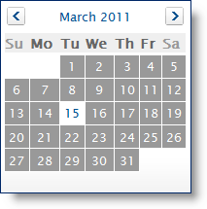
To add an early or late registration option, click on the Allow Early Registration and/or the Allow Late Registration option.
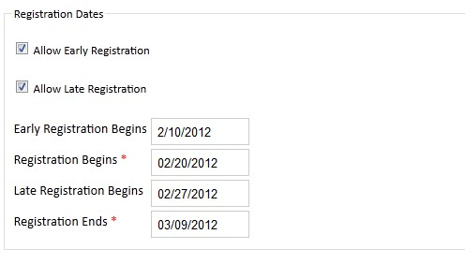

Registration Types
There are four different registration types.
- Attendee: This is typically an individual registrant who is not part of a group.
- Speaker: A person speaking at the Event.
- Group: Two or more people who register together. Minimum and maximum numbers can be set for groups.
- Vendor/Exhibitor: A person or company hosting a booth or kiosk at the Event.
IMPORTANT:
The system does not prioritize or differentiate between registrant types; capacity is filled on a first come-first served basis. If you set a maximum number of attendees for your event, make sure to allow time for speakers to register before opening up registration to the public in order to avoid the problem of a speaker not being able to register because the event is sold out. In the event that you need the option to manually register someone, you may do so as an Event Administrator. (See the Event Management > Add Attendee section.)
At least one registration type must be selected. Each registration type can have a different registration fee assigned to it.
Each registration type can also have access to specific Activities (see: Event Setup > Activity Details). You also have the option to make some activities mandatory for each registration type.
Select the Registration Type option(s) for the Event.
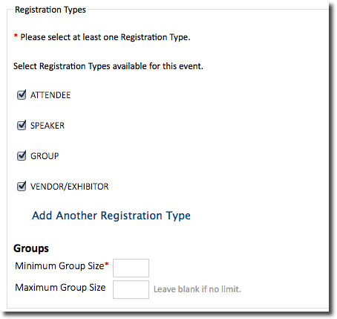
If Group is selected, enter the Minimum Group Size (required field) and the Maximum Group Size (optional).
If there is no limit to the size of a group, leave the Maximum Group Size field blank.
Then click Continue.

Governement Affiliation
If the affiliation of the attendee is desired, utilize the Government Affiliation options. Select either one or multiple options: State Agencies, Local Government or Other, to define the affiliation options, which will display to the registrant. You may utilize the default lists for state agencies or local government or you may define your own list.
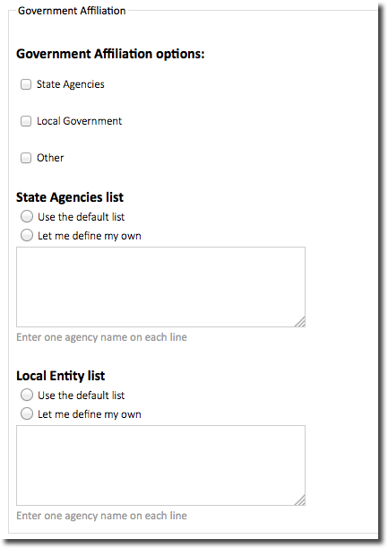
Click ‘Continue’ to proceed

Error Notifications
If required fields are left blank or do not meet the field parameters, an error message will display at the top of the screen. The system will not allow the Event creation process to continue until all required fields on that screen meet the defined parameters.
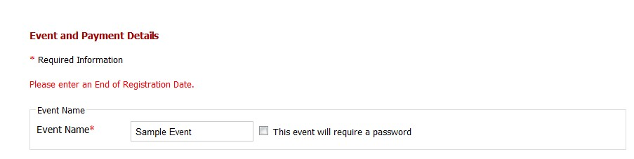
Read the error message displayed at the top of the screen and resolve any issues.
Then click Continue again.

Event Setup

Activity Details
Multiple activities can be added to an Event. Each activity can be required or optional.
Enter the Activity Name.
Enter a Description of the activity.
Enter a date or date range in the Dates fields. If an activity only lasts one day, you may leave the second field blank.
If the activity is required for all attendees, check the box marked This activity is required.
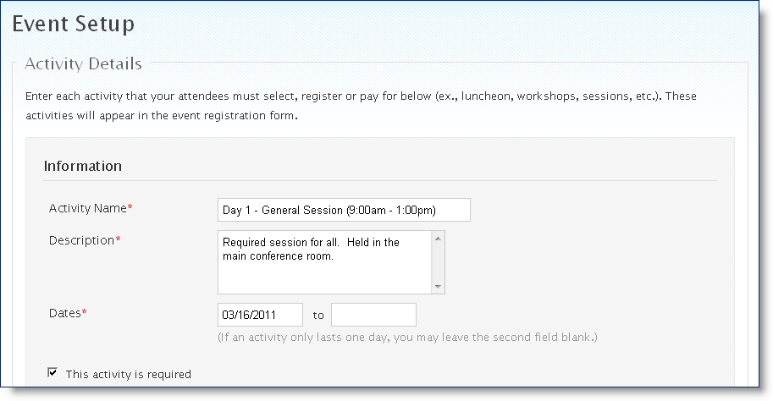
NOTE:
The system does not allow you to set a specific time for an activity. You can use the Activity Name and Description fields to communicate the time and location of each activity to your audience.
The Pricing section allows you to set early, standard, and late registration fees (if these options were selected on the previous screen).
First, select which Registration Types should be included in this activity.
Next, assign registration prices for the fields displayed or enter “0” if a fee will not be charged.
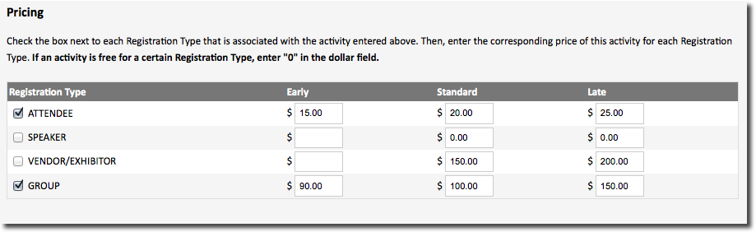
NOTE:
If early and late registration options were not selected on the previous screen, only the Standard column will be displayed.
To add multiple activities, click on the Add Another Activity option.
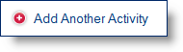
If you select Add Another Activity, another activity entry section will display. Enter the pertinent information for this section.
if the activity is required for all attendees, check the box marked This activity is required.
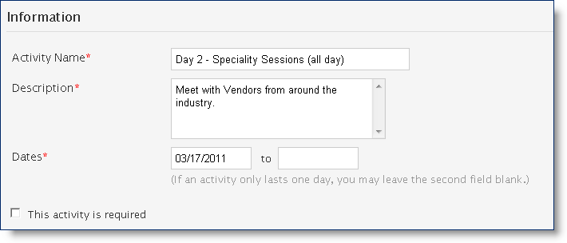
Enter Pricing information for this activity.
To remove the activity, click on the Remove Activity link.
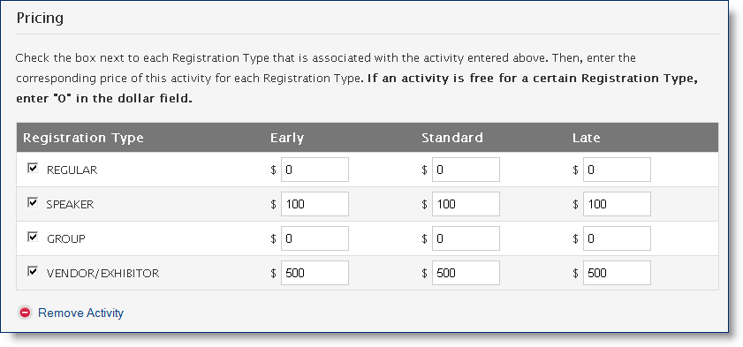

Registration Form Setup

Registration Information
You can request a variety of information from each registration type when she registers for the Event.
Select the information that is required to register for the Event by clicking on each. You may use the Check All option to select all applicable attendee types in a single row.
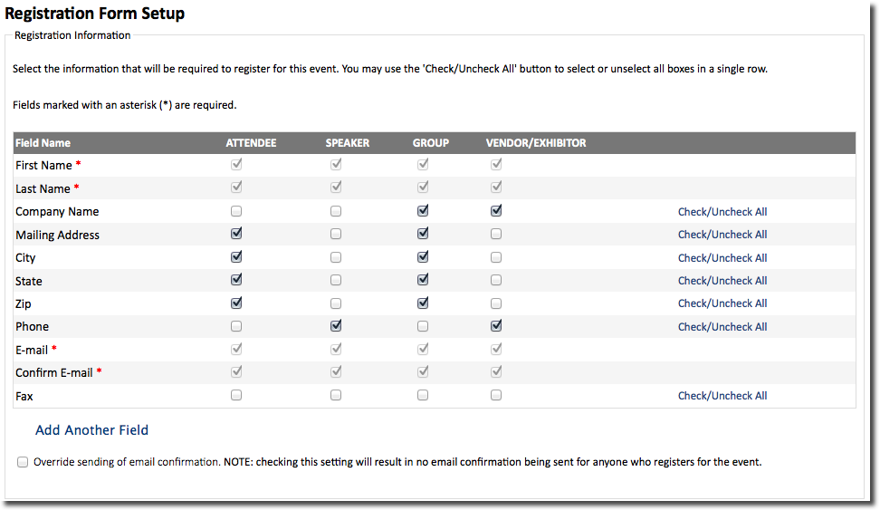
You may also add Custom fields to ask specific questions or request other information.
To add a custom field, click on the Add Another Field option. The new custom field will display at the bottom of the list.
Enter the Field Name (or ask the registrant a question) in the blank field.
Select which registration type(s) must see this field when they register.
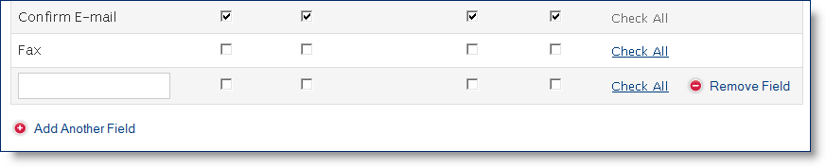
To delete a custom field, click on the Remove Field option located at the end of that field’s row.
NOTE:
You can add as many custom fields as you want.

Event Questions
Additional standard questions are available.
Click on the box next to these standard questions to make them part of the registration process.
You may opt to allow registrants to bring Guests to the event. You may also indicate a fee amount for each Guest.
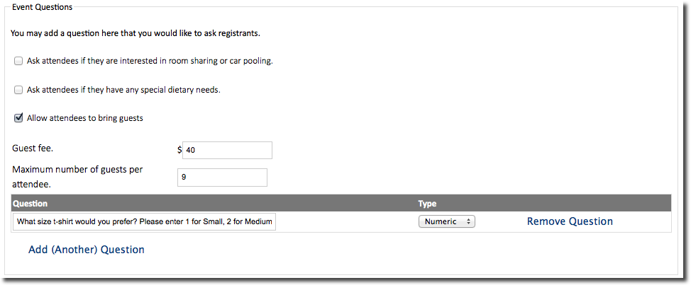
You may also add Custom questions or request other information. You must formulate the question in a manner that may be answered either Yes or No or have a numeric value.
To add a custom field, click on the Add (Another) Question option. The new custom question field will display at the bottom of the list. Select the Type of answer “Yes/No” or “Numeric”.

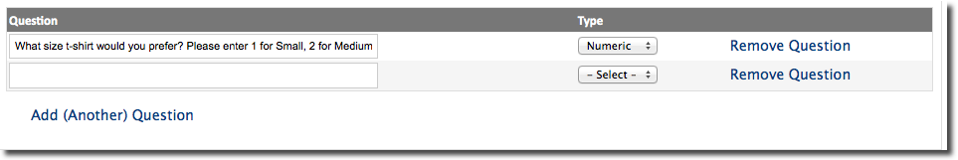

Event Capacity
A maximum number of attendees can be set for an Event.
Enter the Maximum Number of Attendees. If the Event does not have a registration limit, leave this field blank.
Enter a Sold Out Message (optional) for anyone who tries to register after the maximum number of attendees is reached.
To enable a waiting list, click on the Allow Waiting List option.
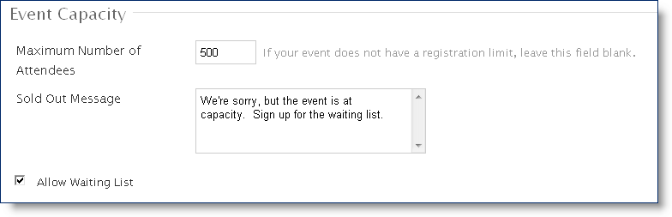

Waiting List
If the waiting list option is enabled, the system will alert the registrant that the event is full and they can sign up for the waiting list after they have entered information on the registration page but before payment processing.
IMPORTANT:
It is important to capture contact information because the system does not have an automated method in place to contact an individual if a space becomes available.
NOTE:
The system does not HOLD a registration spot open for a specific individual. If there is a cancellation and you contact the first person on the waiting list, someone else may register before the person you contact is able to.

Event Homepage

Content
To add a logo to the registration page, click Browse.
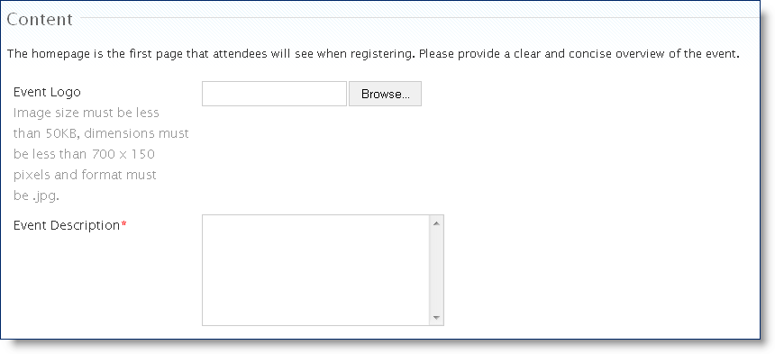
Navigate to the logo you want to upload.
Then click Open.
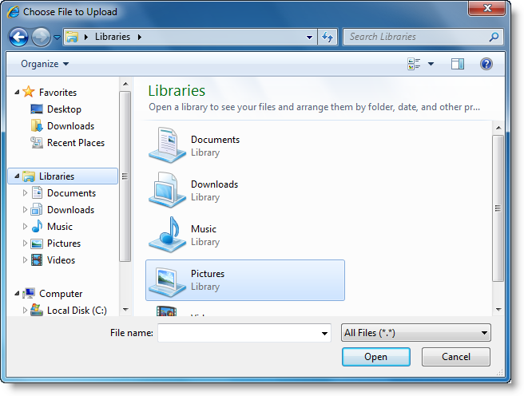
NOTE:
Make sure that the logo meets size and dimension requirements provided on the screen (Less than 250KB, dimensions less than 700x150 pixels and format must be .jpg, .gif or .png.)

Document Links
To upload a document (e.g., a conference schedule or map to the event), enter a Document Name.
Then provide a URL link to the document.
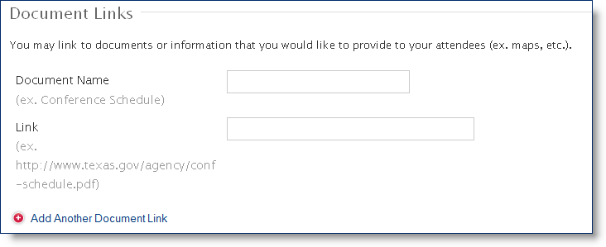
NOTE:
You can upload logos to the system but you cannot upload documents. You must first put documents online in a publically accessible location (not behind a password protected firewall unless your audience has access) and then supply the URL link to that location.

Verify Event Information
The last step in the Event creation process is to review all of the information you entered.
Review all information on the Verify Event Information screen.
To make edits, click on the Edit button at the bottom of the section that needs to be edited.
When you are finished, click Save Event.
IMPORTANT:
Any information you add or change on the previous screens will not be saved unless you come to the Verify Event Information page and click Save Event.

Duplicate an Event
Once an Event is created, it can be used as a template for future events. This is a helpful feature because the Event retains all event details, including applicable service codes.
- To Duplicate an Event, go to the Event Dashboard.
- By clicking on the Duplicate Event link next to the event that you want to duplicate, you will create a new event with all of the same parameters as the original.

Event Management
Once an Event has been created, there are several options available to manage the Event and registrant data.
From the Actions section, the Event Administrator can:
- Edit the Event
- Manually Add an Attendee
- Create Name Badges
- View and Manage the Waiting List
- Send Email Notifications to the different registrant types
- Create Reports
- Disable the Event

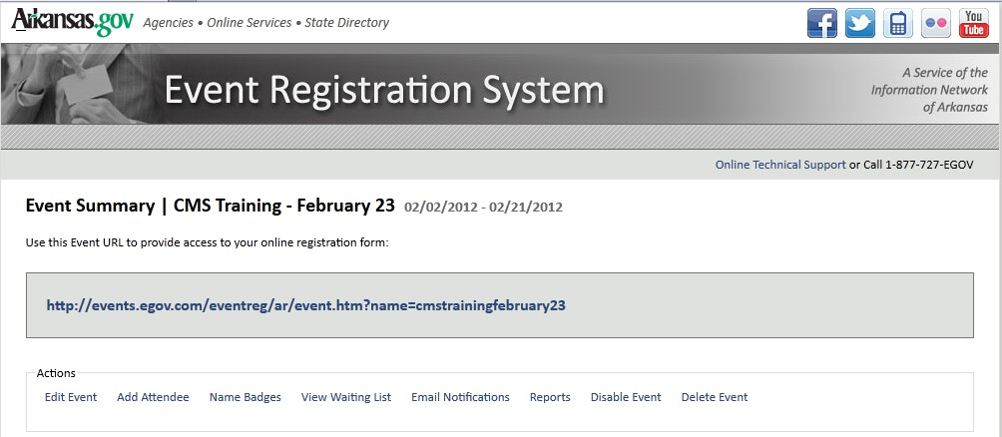

Event Summary
- To access the Event Summary, click on an Event Name on the Events Dashboard.

Event URL
The first item listed is the Event URL. This link takes registrants to the registration page.

Actions
The Actions section is the main navigation tool to manage Event and registrant data.
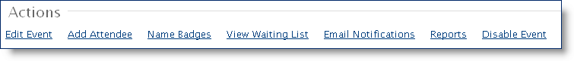

Details
The Details section gives a summary of the Event.
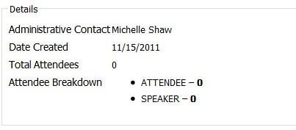

Attendees
The Attendees section lists all Event attendees. You can search this list by either first or last name.
- To search for an attendee, enter the attendee’s first or last name. Then click Search.
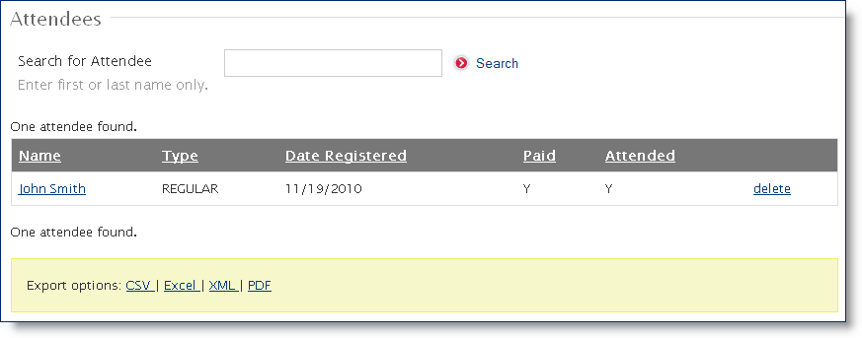
NOTE:
Only the first OR last name can be used to search for an attendee.
- Click on the attendee’s name to display that attendee’s information.

Registrant Information
All of the information entered at the time of registration is displayed.
To mark this registrant as a no show, click on the Attendee is No Show option.
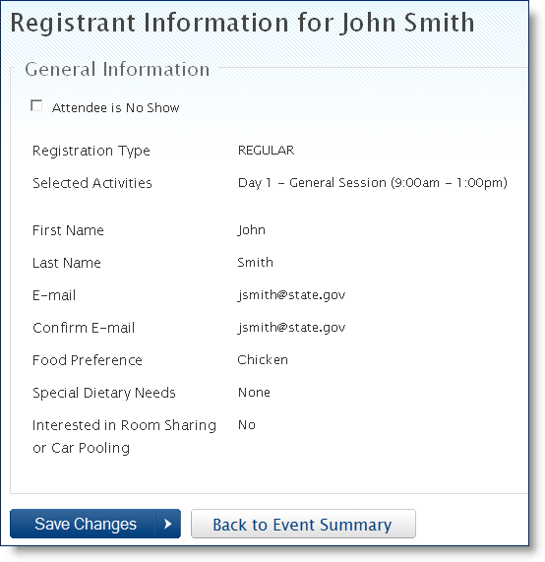

Delete Attendee
To delete an attendee, click on the delete link to the right of their name.
Then click the Delete User button to confirm deletion of this attendee.
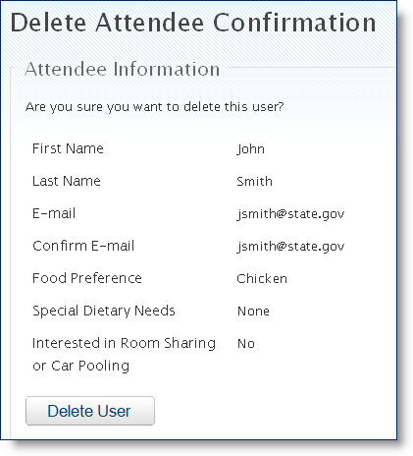

Export
You can export the entire attendee list using the Export options provided.
To export the attendee list, select a format by clicking on one of the Export options.

Edit Event
Editing an Event follows the same process as creating a new event (see: Creating an Event for details).
- To edit an event, click on Edit Event from the Events Summary screen.

Add Attendee
Manually adding an attendee follows the same process the registrant uses when registering for an Event.
- Click on Add Attendee from the Events Summary screen.

Start Registration
Select a Registration Type.
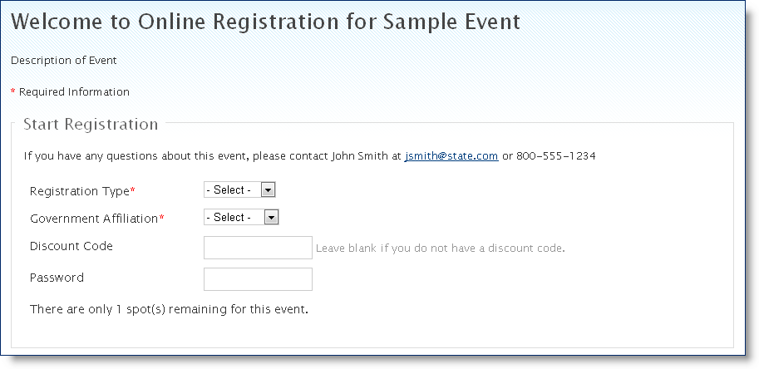
Registration Types listed here are the types selected when the event was created.
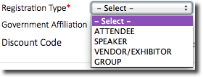
Select a Government Affiliation.
Options for this list are State, Local, and Other/None.
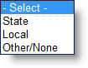
If State is selected for Government Affiliation, the State Agency is also required.
Select a State Agency from the drop down list.
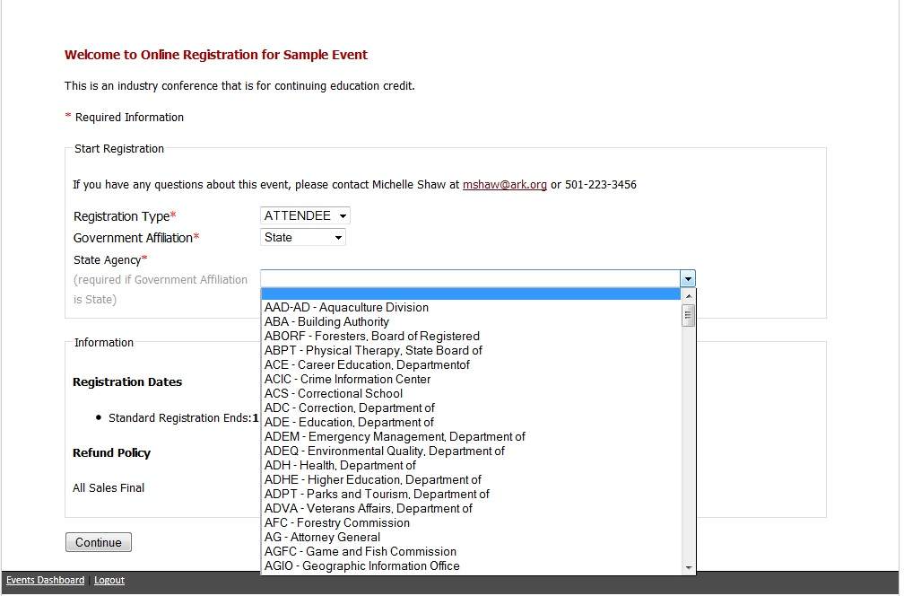

Enter a Discount Code (if available).
Enter a Password (if required).

Information
Event information is displayed below.
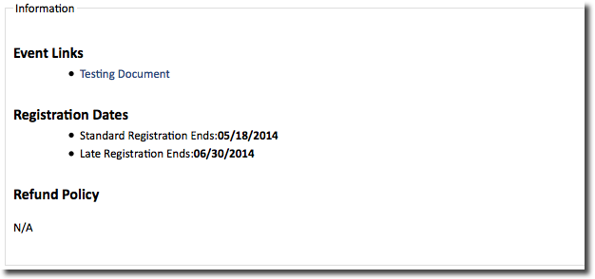
Click Continue to proceed.

Activity Details
Details about each activity are listed next.
Click on the Sign up for this activity option next to each activity the registrant wants to attend.
Then click Continue.
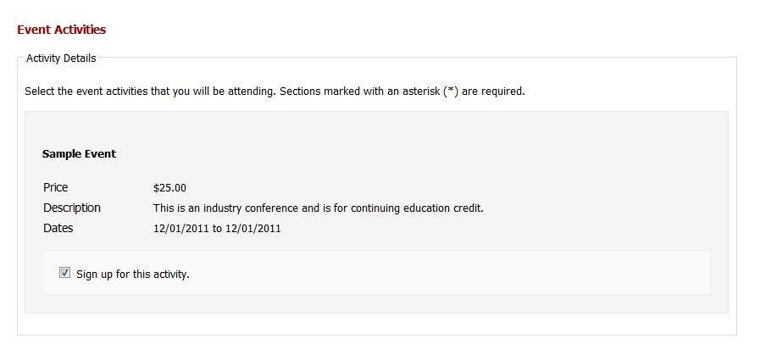

Contact Information
Enter the registrant’s Contact Information.
If the Group option was selected, click on the Add Another Attendee to This Group to add more attendees.
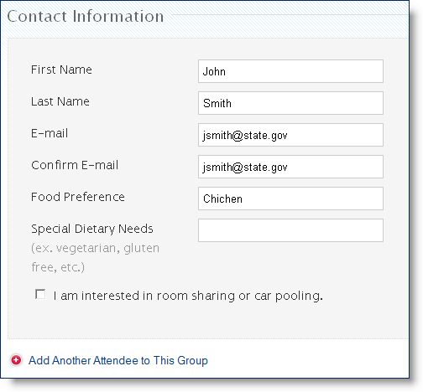
To remove attendees from a group, click on the Remove This Attendee option.
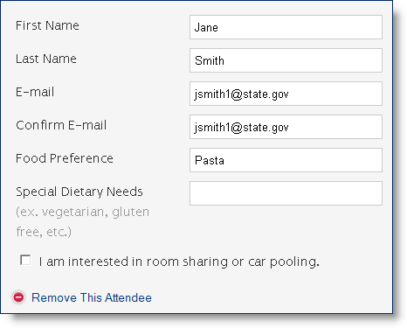
When finished, click Continue.
Verify that the information entered is correct.
Click Edit Information to make changes.
When finished, click Continue.
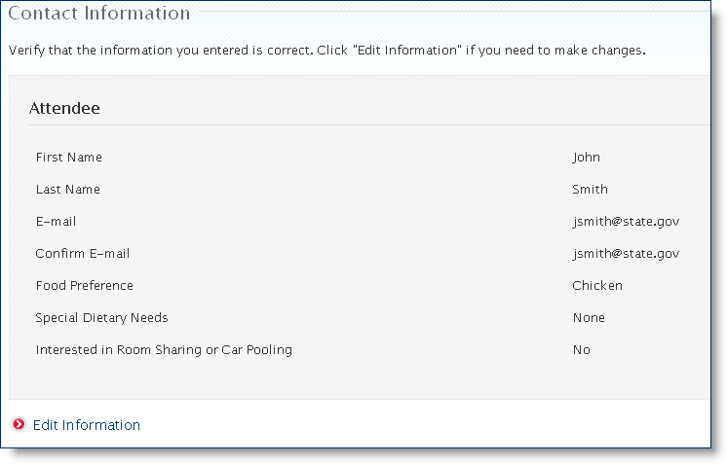

Waiting List
If the Event is full and the Waiting List option was selected, the registrant can elect to join the waiting list and will receive verification of waiting list status and any next steps needed in the message shown below.
To enter the waiting list, complete the Name, Email, and Phone Number fields.
Then click Join Waiting List.
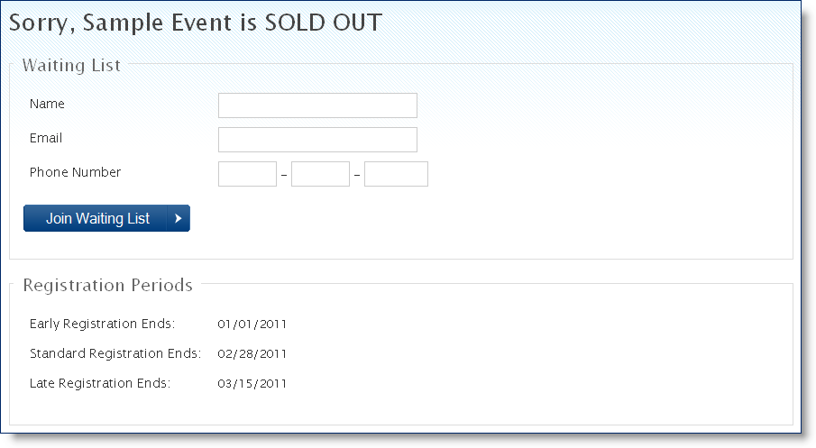
Confirmation of successful addition to the waiting list will display.
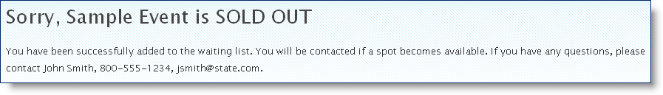

Payment Process
Once the registrant’s information is entered (and if the Event is not full), the next step is to complete the payment process (if there is a charge for the Event).
- Select a Payment Method.
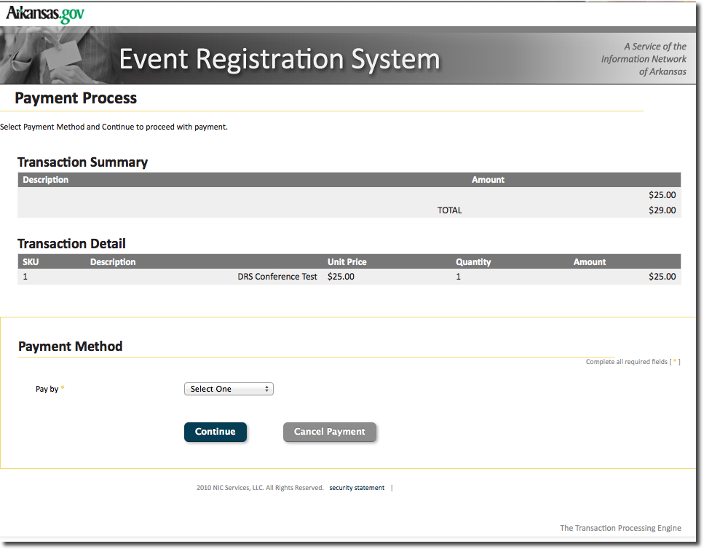
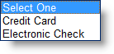
NOTE:
At this time, the system only accepts two payment methods: Credit Card and Electronic Check. The system defaults to the highest transaction portal fee amount on the first screen. Once payment type is selected, if the fee for that type is lower, the system will reflect that.

Customer Billing Information
The next section captures the registrant’s billing information (same for both Credit Card and Electronic Check).
Enter all required fields that are marked with an asterisk (*).
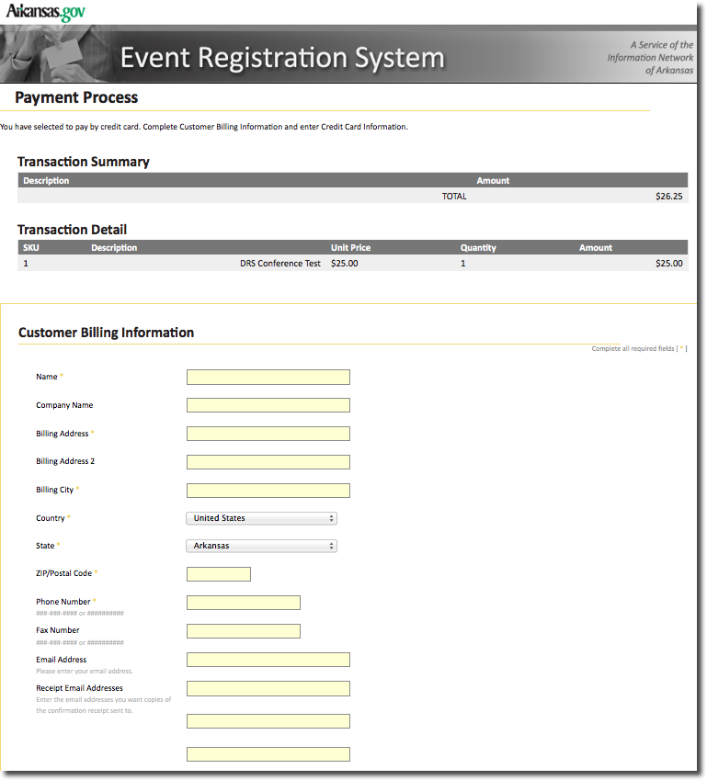

After the Customer Billing Information is captured, the Credit Card or Electronic Check information follows.

Credit Card Information
Select a Credit Card Type.
Then complete the remaining required fields.
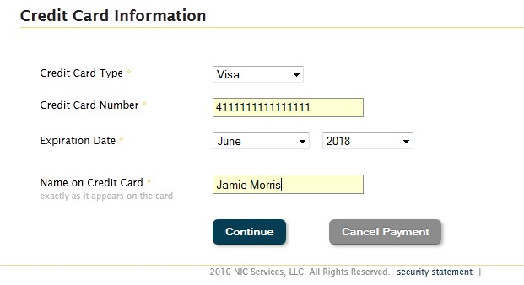
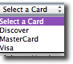
When finished, click Continue.

Verification
Payment Verification is the final step in the payment process.
Review the payment information and click Make Payment to proceed.
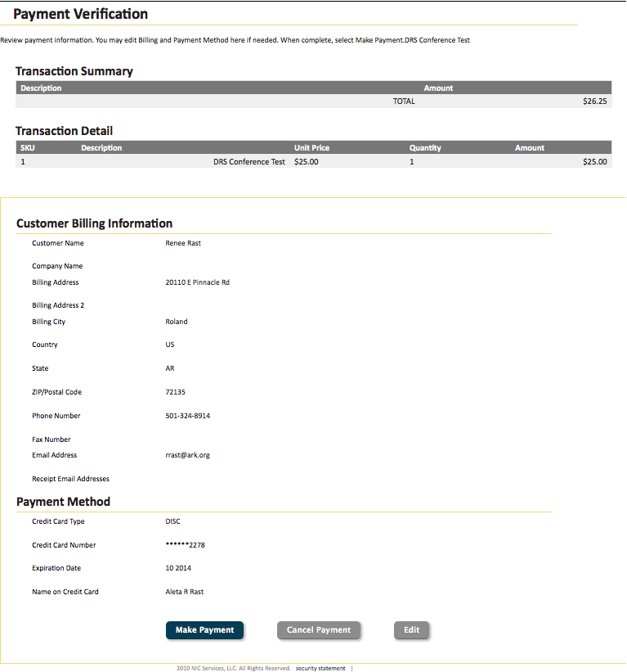

Electronic Check Information
If Electronic Check is the selected payment option, select an Account Type.
Complete all other required fields.
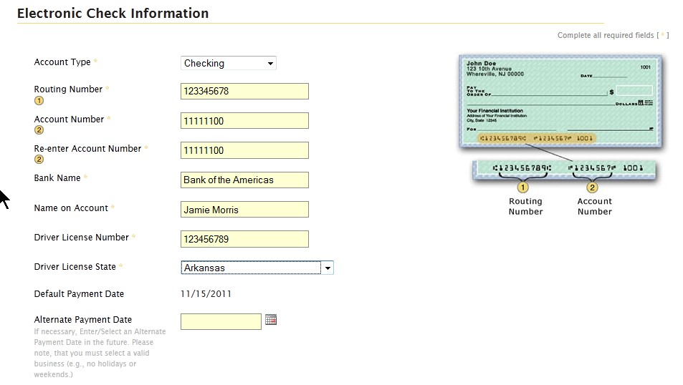
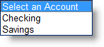
If the payment is being funded specifically by a foreign source (bank or company), an International ACH Transaction (IAT), click the box next to the text at the bottom of the screen.
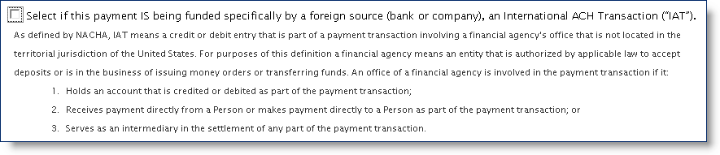
Then click Continue.

Verification
Payment Verification is the final step in the payment process. Review payment information and click Make a Payment.

Payment Confirmation
Once payment has been accepted, the Payment Confirmation screen will display. This includes Details and a Payment Summary.

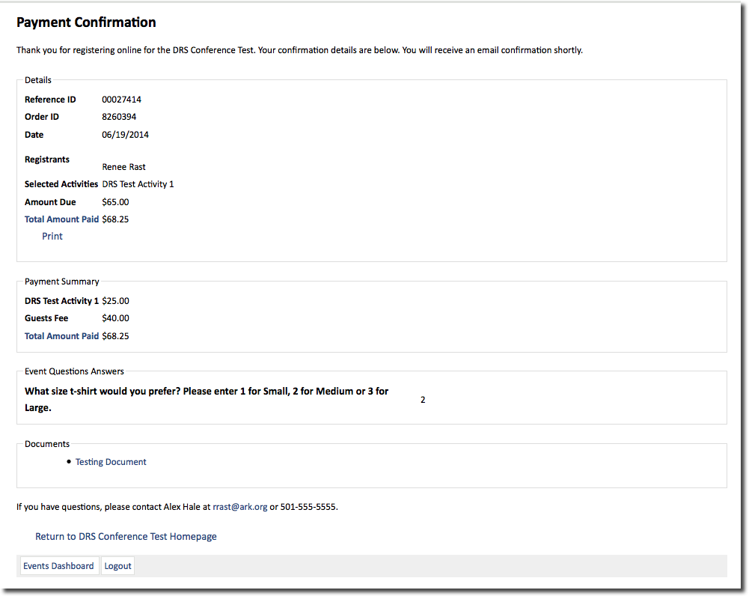

An email confirmation will also be sent to the email address entered during the registration process.
Click on the Return to Event Homepage link when finished.

Name Badges
The option to print name badges is accessible from the Events Summary screen.
- Click on the Name Badges link from the Actions section of the Events Summary screen.

Name Badge Information
The image displayed shows the layout of the name badge that the system can print.
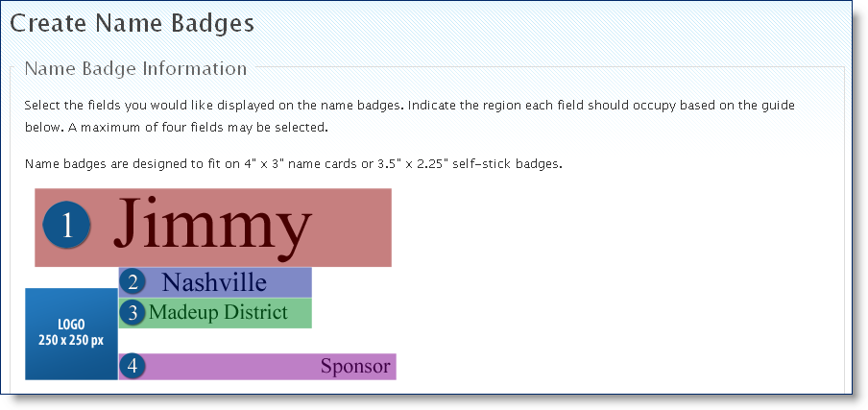
Select the fields that should appear on the name badge by checking those options from the Fields to Use column.
Enter the number of the region next to each field in the Region on Badge column.
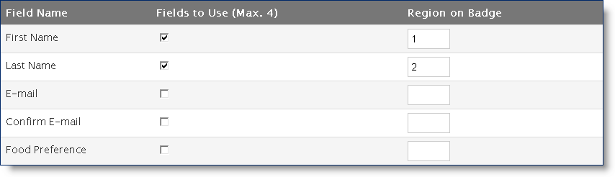
Next, select a Badge Size from the drop down list.
To include a logo on the badge, click on the Browse button.
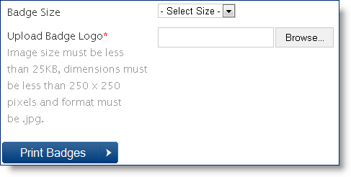
Navigate to the logo to be uploaded.
Then click Open.
NOTE:
Make sure that your logo meets size and dimension requirements listed on the screen.

View Waiting List
The option to view and manage the waiting list is accessible from the Events Summary screen.
Click on the View Waiting List link from the Actions section of the Events Summary screen.
The only option here is to remove someone from the list.
Click on the Remove link to the right of their name.
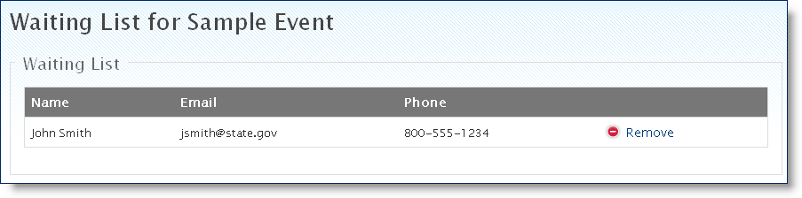
NOTE:
Managing the waiting list is a manual process. The system will not automatically contact someone from the waiting list, nor will it automatically register someone who has signed up for the waiting list. If necessary, you will have to manually contact people from this list.
IMPORTANT:
Remember, the system will not save an open registration slot for a specific person. If someone else registers and fills the final slot while you are contacting the next person on the waiting list, it could cause confusion to the person you contacted.
Tactics for working around this issue could include removing all previous passwords and creating a new password that is only shared with the people contacted from the waiting list.

Email Notifications
The option to send email notifications to all registrants or everyone within a specific registration type is accessible from the Events Summary screen.
Click on the Email Notifications link from the Actions section of the Events Summary screen.

Email Messages:
Select the registration types that should receive the email.
Enter a Subject and content into the Body section.
Then click Send Email.
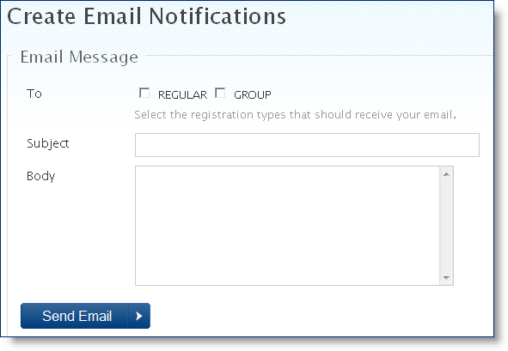
NOTE:
You can create the message in a program with spell checking (Word), then paste the text into the Subject and Body fields.
See the email templates reference in the Portal Set Up Guide for more information.

Reports
The option to create reports and export the data to another format (Excel, CSV) is accessible from the Events Summary screen.
Click on the Reports link from the Actions section of the Events Summary screen.

Report by Date
Enter a Date Range.
Click on the Run Report link.
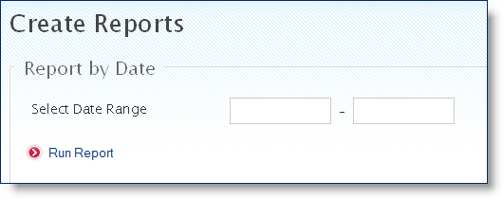
Click to Open or Save the document.
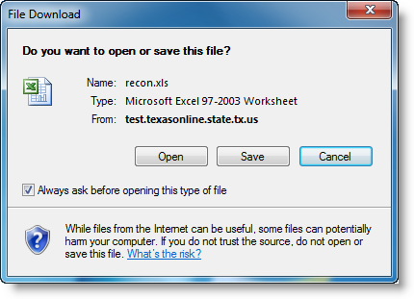
This report is different than the All Event Data report. It shows data specific to the registration process including attendee types and if a discount code was used.
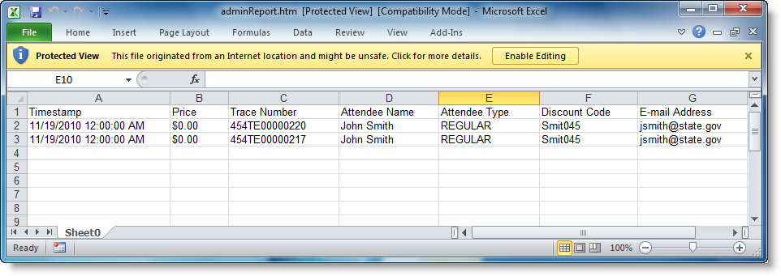

All Event Data
You can also run a report for all event data. This report includes all registration fields completed by registrants including custom fields.
To create a report for all registration data, click on the Excel or CSV link at the bottom of the screen.
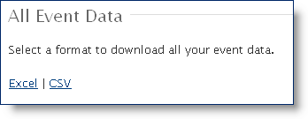
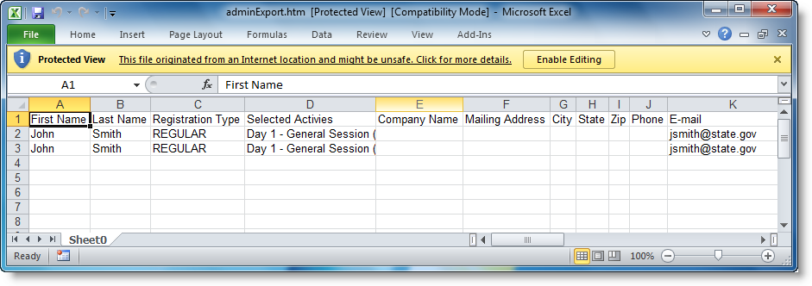

Disable Event
An Event can be disabled from the Events Summary screen.
IMPORTANT:
Once an Event is disabled, the URL will also be rendered inactive. However, you can still run reports on registrant data from a disabled event.
- Click on the Disable Event link from the Actions section of the Events Summary screen.
Click Disable Event to finalize the process.
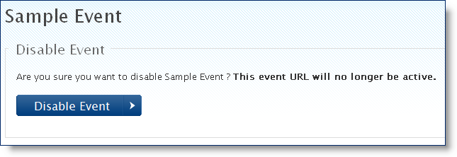
After an event is disabled, a notification is listed in the Event Title at the top of the screen and the Actions section will only allow limited functions.

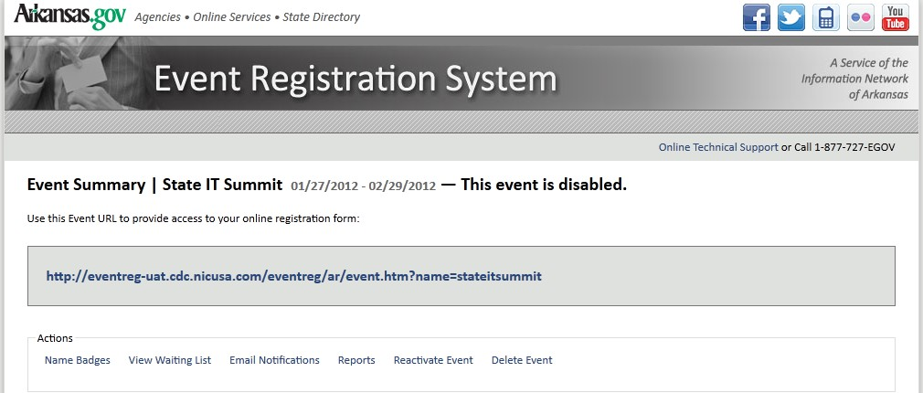

Reactivate Event
Once an Event is disabled, the option to Reactivate the Event is now active in the Actions section.
To make an Event active again, click on the Reactivate Event link.
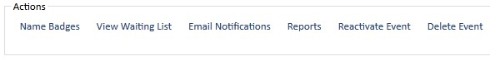
Then click Reactivate Event. This also reactivates the event URL.
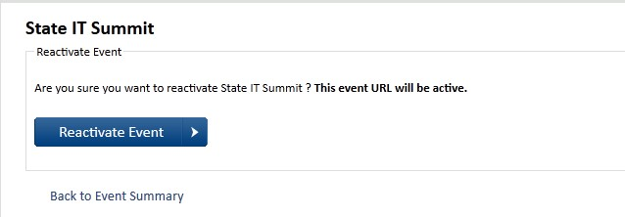

Session Timeout
If you do not save within the 60 minute session window, the system will time out. If this happens, all data that has not been saved will be lost.
Log in to return to the Events Dashboard.

